CHAPTER 4. DEFECT REPORT & METRICS

4.1. Bug Management Tool and Workflow
This chapter explains how defects were controlled, documented, and summarized during the testing process. Because the course requires a real bug-management tool, the project used GitHub Issues as the official issue-tracking platform for confirmed defects. Defect records were synchronized between the issue tracker, the defect register, the final results workbook, and the supporting screenshots and runner outputs.

4.1.1. Selected tool
GitHub Issues was selected as the official bug-management tool for this submission. The tool is appropriate for the project because it supports issue IDs, labels, screenshots, comments, status tracking, and direct linking from the final result package. It also satisfies the course requirement to use a real issue-management platform rather than a manually typed bug list only.
The selected tool was used for the four confirmed defects that remained reproducible in the current execution baseline.
Table 4.1. Bug-management tool selection
Item | Value
Selected tool | GitHub Issues
Repository | Alucard30Dec/Online-Sales-Management-System
Used for | Confirmed product defects with reproducible evidence
Linked artifacts | Defect register, final results, screenshots, TRX/TXT/XML evidence
Reason selected | Real issue IDs, practical traceability, and direct repository integration

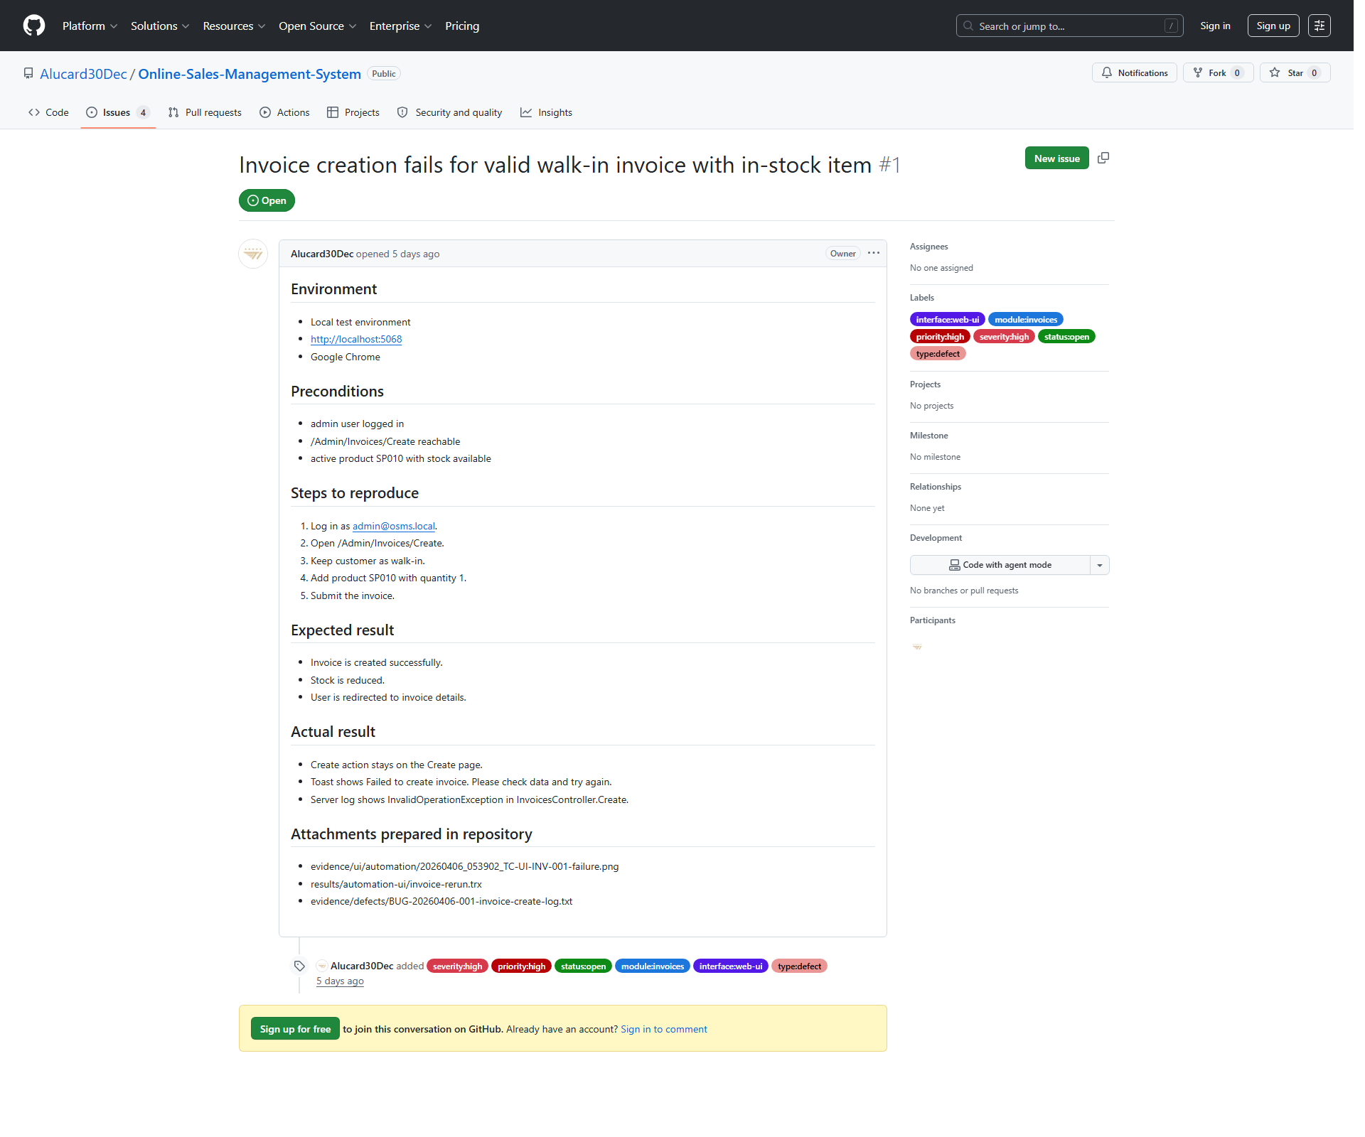
Figure 4.1. GitHub Issue example used as the official bug-management record for a confirmed defect.

4.1.2. Issue workflow
The issue workflow used in this submission was designed to keep defect reporting disciplined and evidence-based. An issue was created only after the mismatch was reproducible and supported by execution artifacts.
• execute or rerun the related test case
• compare actual behavior against the expected result
• collect screenshots and runner outputs
• classify the result as observation or confirmed defect
• open a GitHub Issue for reproducible confirmed defects only
• link the issue back to the defect register and final results workbook
• keep the issue open until a real post-fix retest can verify closure
Table 4.2. Issue workflow
Step | Action | Expected output
1 | Execute or rerun the test case | Observable system result
2 | Collect screenshot and runner evidence | Supporting proof files
3 | Compare expected and actual behavior | Pass / Fail decision
4 | Classify as observation or confirmed defect | Defect triage decision
5 | Create GitHub Issue for confirmed defects | Live issue record with labels
6 | Sync register, results, and evidence mapping | Full traceability across artifacts
7 | Retest after fix when available | Potential closure or continued open status

4.1.3. Severity and priority rules
Severity and priority were assigned according to business impact, reproducibility, and operational risk. The project used simple but defensible rules so that each rating could be justified during presentation defense.
Table 4.3. Severity and priority rules
Rule area | How it was applied in this project
Severity: High | Used when the defect blocks a core business workflow such as invoice creation, invoice cancellation, or valid product import confirmation
Severity: Medium | Used when the system blocks invalid input correctly but still presents broken or unreadable validation feedback
Priority: High | Used when the defect affects transaction correctness, inventory, or core operational workflow
Priority: Medium | Used when the defect should be fixed but does not fully break the core transaction path

The actual issue labels used in GitHub include:
• severity:high / severity:medium
• priority:high / priority:medium
• status:open
• module:invoices / module:purchases / module:product-import
• interface:web-ui
• type:defect

4.2. Defect Log
At the current reporting point, the defect register contains 4 confirmed defects and 2 closed observations. The observations are retained for historical traceability, but only the confirmed defects are counted as current product defects in the summary metrics.

4.2.1. Critical and high severity defects
No active critical-severity defect exists in the current baseline. However, three high-severity defects remain open and affect core business workflows. These defects are the most important findings of the submission because they directly affect invoice processing, inventory-related behavior, or valid import completion.
Table 4.4. High-severity confirmed defects
Defect ID | Related test case(s) | Module | Severity | Priority | Current status | GitHub Issue
BUG-20260406-001 | TC-UI-INV-001; TC-UI-INV-003; TC-UI-INV-006 | Invoices | High | High | Open - Confirmed | https://github.com/Alucard30Dec/Online-Sales-Management-System/issues/1
BUG-20260411-003 | TC-UI-IMP-003 | Product Import | High | High | Open - Confirmed | https://github.com/Alucard30Dec/Online-Sales-Management-System/issues/3
BUG-20260411-004 | TC-UI-INV-005 | Invoices | High | High | Open - Confirmed | https://github.com/Alucard30Dec/Online-Sales-Management-System/issues/4

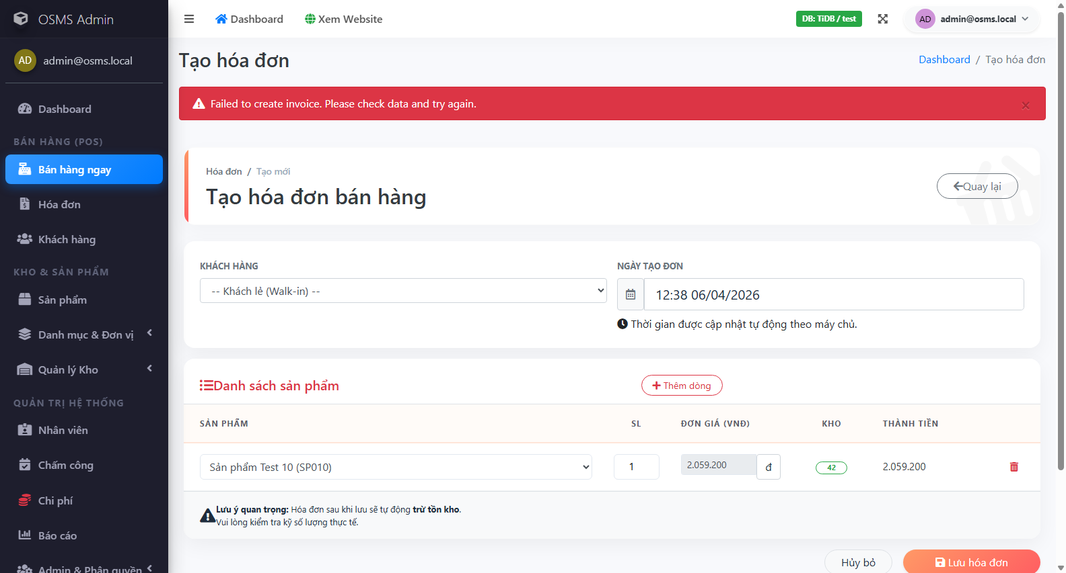
Figure 4.2. Reproduction evidence for the high-severity invoice creation defect.

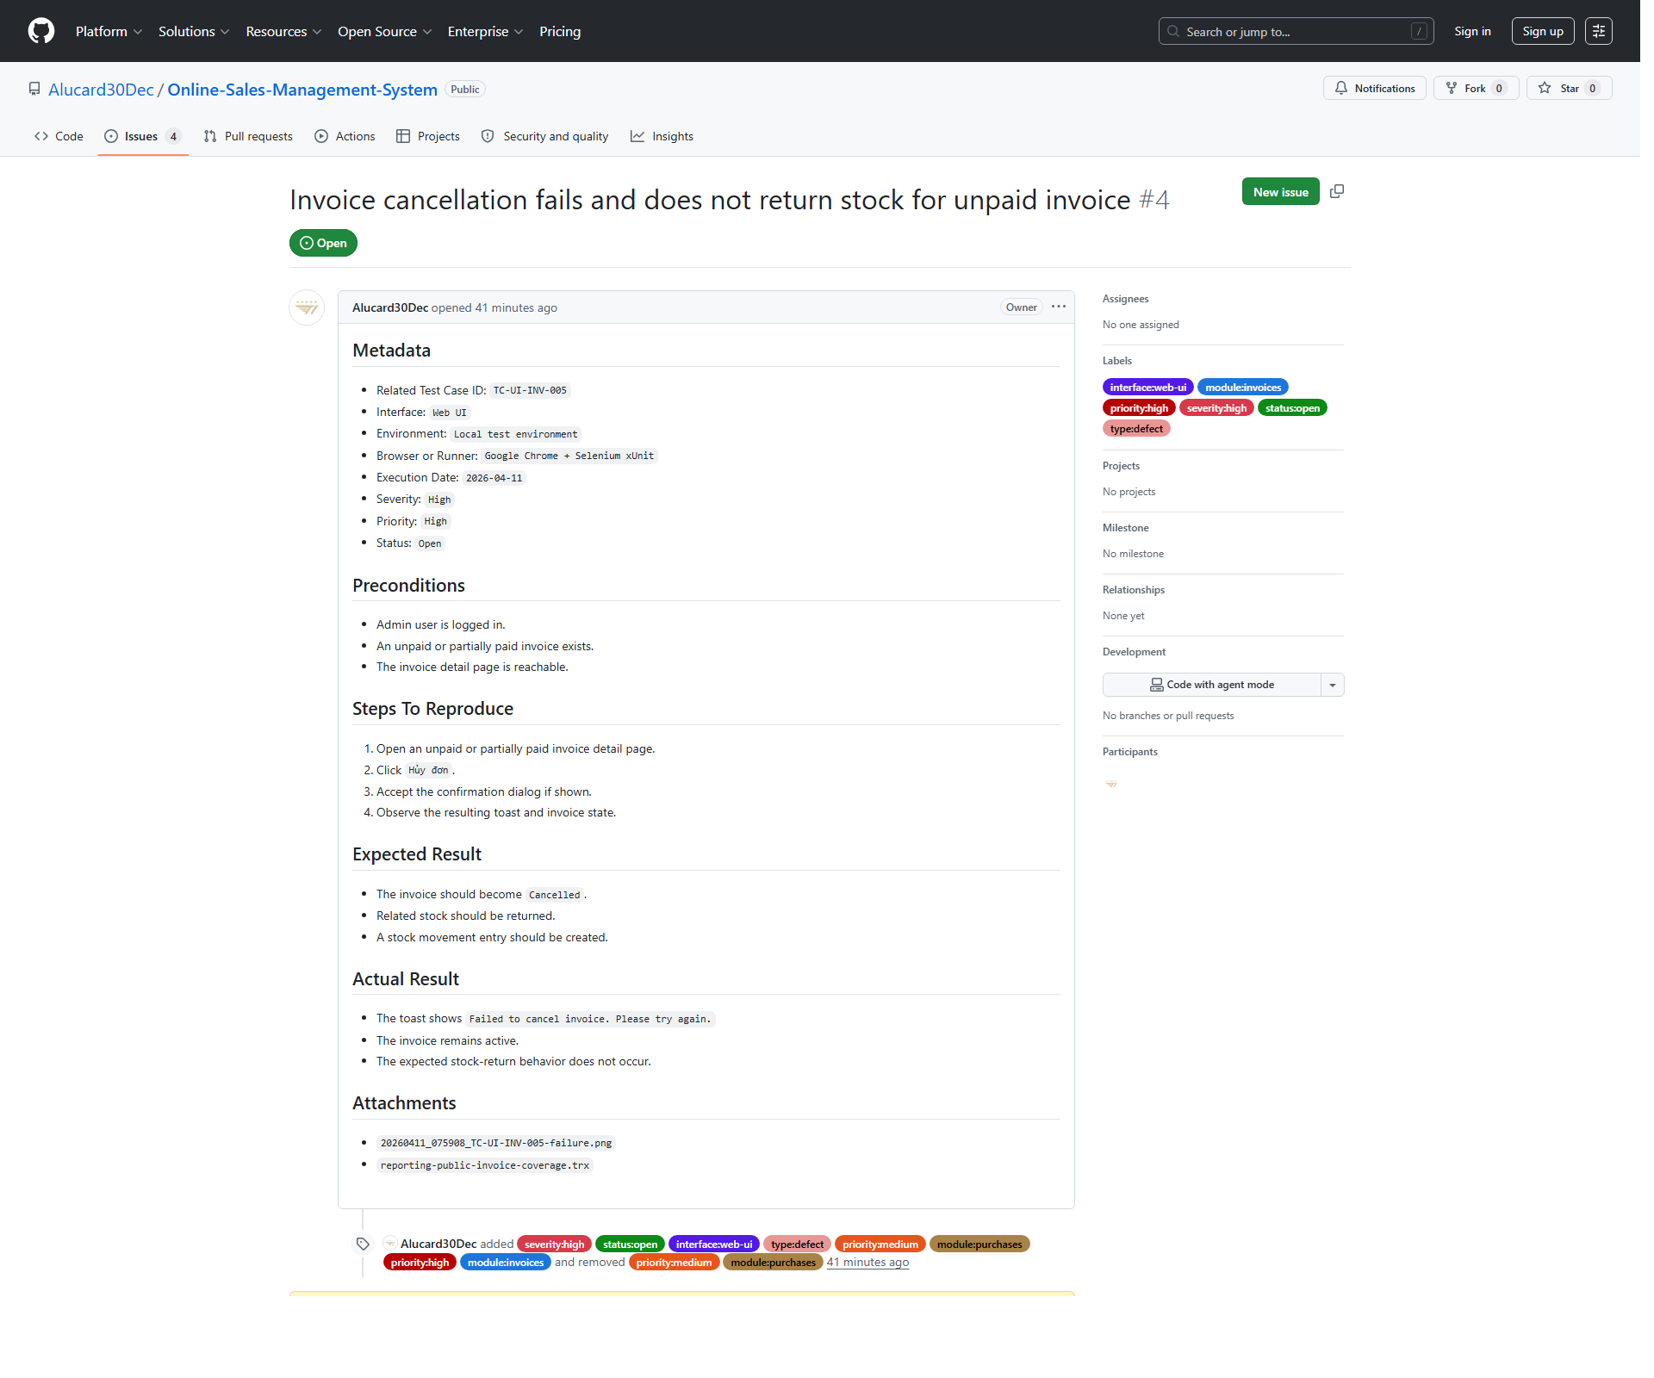
Figure 4.3. GitHub Issue evidence for a high-severity invoice cancellation defect.

4.2.2. Medium and low severity defects
The current baseline contains one medium-severity confirmed defect and no low-severity confirmed defect. The medium defect does not break transaction blocking logic itself, but it still degrades the quality of system feedback by rendering an unreadable validation banner in the purchase-create flow.
Table 4.5. Medium and low severity confirmed defects
Defect ID | Related test case(s) | Module | Severity | Priority | Current status | GitHub Issue
BUG-20260411-002 | TC-UI-PUR-002; TC-UI-PUR-003 | Purchases | Medium | Medium | Open - Confirmed | https://github.com/Alucard30Dec/Online-Sales-Management-System/issues/2
Low severity defects | None | - | Low | - | - | -

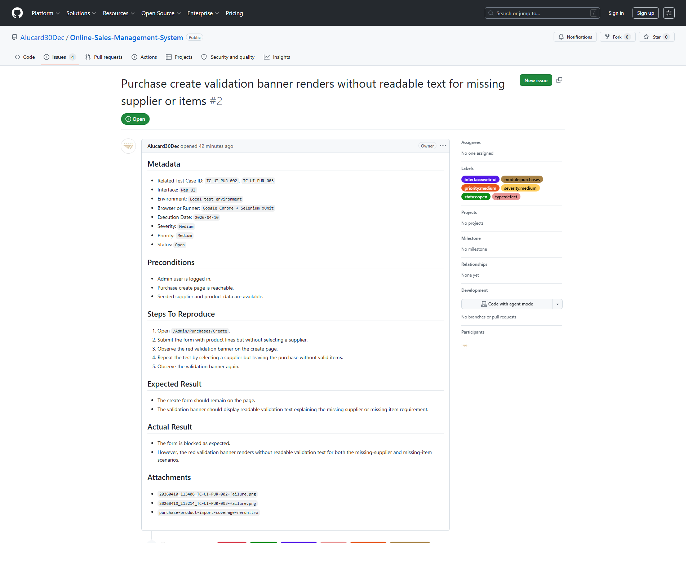
Figure 4.4. GitHub Issue evidence for the medium-severity purchase validation defect.

4.2.3. Screenshots and reproduction evidence
Every confirmed defect in the current baseline is supported by reproduction steps and at least one screenshot or runner artifact. The strongest defect packages also include retest evidence and direct GitHub Issue screenshots. This evidence design improves traceability and makes the defect records defensible during presentation review.
Table 4.6. Defect evidence mapping summary
Defect ID | Evidence types used | Purpose
BUG-20260406-001 | UI screenshots, TRX, server log excerpt, GitHub Issue screenshot | Proves invoice-create failure is reproducible and not limited to one scenario
BUG-20260411-002 | UI screenshots, focused rerun TRX, GitHub Issue screenshot | Proves purchase validation banner defect is reproducible
BUG-20260411-003 | UI screenshots, focused rerun TRX, GitHub Issue screenshot | Proves import confirmation still fails after valid preview
BUG-20260411-004 | UI screenshots, focused rerun TRX, GitHub Issue screenshot | Proves invoice cancellation still fails and stock return does not occur

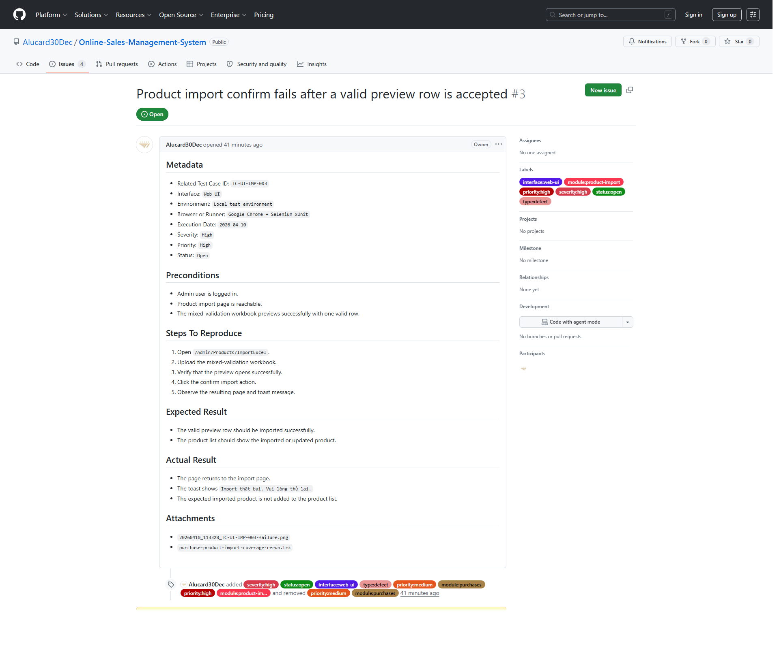
Figure 4.5. GitHub Issue evidence for the product-import confirmed defect.

4.3. Test Summary Metrics
The test summary metrics describe the final execution state of the current baseline. It is important to distinguish between failing test cases and unique confirmed defects. In this project, 7 test cases currently report Fail, but those failures map to 4 unique confirmed defects because multiple failing cases are caused by the same underlying issue.

4.3.1. Total test cases executed
The current baseline contains 63 executed test cases. According to the synchronized final-results workbook, all designed UI and API cases in the baseline have recorded execution results, which means execution completeness is 100%.
Table 4.7. Execution totals
Metric | Value
Total test cases | 63
Executed test cases | 63
Execution progress | 100%

4.3.2. Pass/Fail/Blocked statistics
The current execution baseline contains 56 passing test cases, 7 failing test cases, and 0 blocked test cases. This gives a pass rate of 88.89% and a fail rate of 11.11%.
Table 4.8. Pass / Fail / Blocked statistics
Status | Count | Interpretation
Pass | 56 | Expected behavior matched real execution evidence
Fail | 7 | Observed behavior did not match the expected result
Blocked | 0 | No blocked cases remain in the current baseline

4.3.3. Defect count by severity
Severity distribution should be interpreted using confirmed defects only, not raw failing test cases. The current confirmed-defect profile shows concentration in high-severity business workflows, especially invoice and product-import related behavior.
Table 4.9. Confirmed defect count by severity
Severity | Confirmed defect count
Critical | 0
High | 3
Medium | 1
Low | 0

4.3.4. Defect ratio and observations
The confirmed-defect ratio in the current baseline is 6.35%, calculated as 4 confirmed defects out of 63 executed test cases. This ratio is lower than the fail-case rate of 11.11% because several failing test cases map to the same underlying defect record. This distinction is important for accurate quality reporting.
In addition to the confirmed defects, the defect register also records 2 observations that were closed after rerun analysis. These records remain useful because they show that the team did not automatically classify every unexpected behavior as a product defect. Instead, each mismatch was reviewed and reclassified based on reproducible evidence.
Table 4.10. Defect ratio and observations
Metric | Value | Note
Confirmed defects | 4 | Unique product defects currently open
Failing test cases | 7 | Some failures share the same root cause
Defect ratio | 6.35% | Confirmed defects / executed test cases
Fail-case rate | 11.11% | Failing cases / executed test cases
Closed observations | 2 | Historical mismatch records resolved by rerun analysis

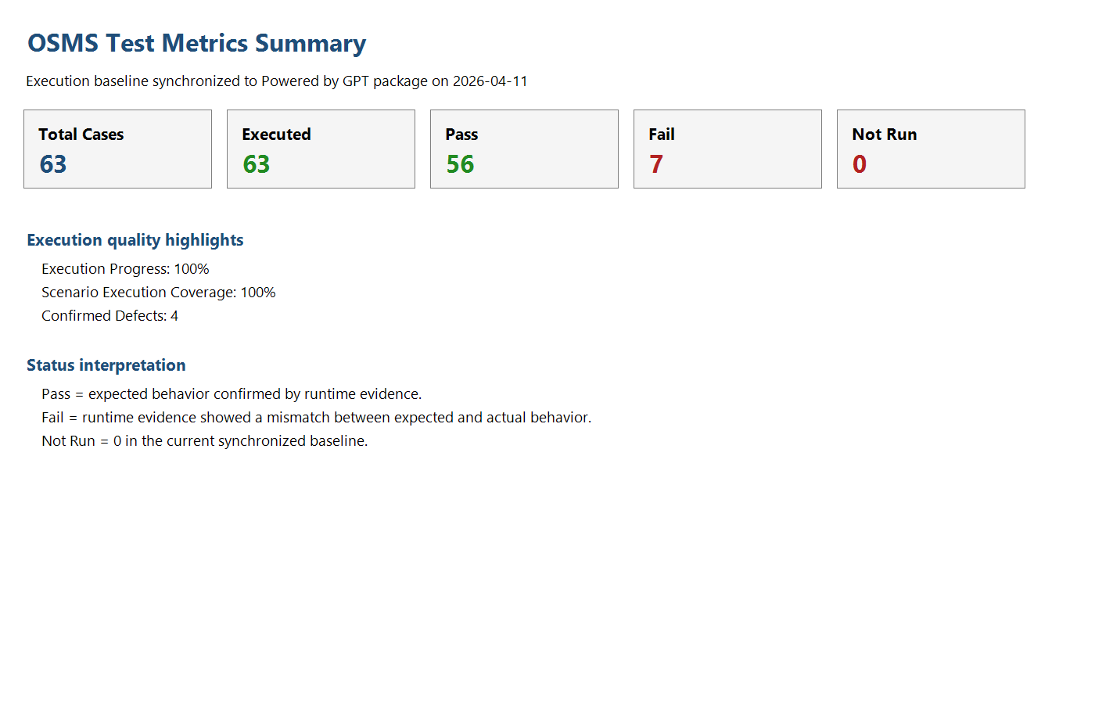
Figure 4.6. Metrics summary exported from the synchronized results workbook.

